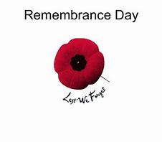
Cornforth Parish Council

Remembrance Day Service

Due to the ongoing Coronavirus Pandemic and taking into account the recently announced national and local government restrictions we regret to advise residents that Cornforth Parish Council will not be able to host the annual Remembrance Day Service on Sunday 8th November.

We understand that this news will be disappointing to those who are usually part of the parade and those who attend to pay their respects. The safety and welfare of the residents and veterans has to be our priority at this crucial time.

To commemorate Remembrance there will be a short service at the War Memorial in the High Street on Sunday 8th November and a wreath will be laid at the memorial in Tursdale. The Parish Council would ask that the public do not attend either of the above events to ensure that the very limited numbers of those allowed to attend, conduct the services and pay respects on behalf of the village, i.e. the clergy and representatives of the Salvation Army and the Parish and County Councils are kept safe. If people do gather, the ceremonies may have to be cut short to ensure that Government Guidance is complied with and people are kept safe – UNLIKE PREVIOUS YEARS THERE WILL BE NO ROAD CLOSURE AT OR LEADING TO THE WAR MEMORIAL.

Please avoid attending the War Memorial in Cornforth between the hours of 10.30am and 11.30 am on the Sunday 8th November to allow the event to proceed unhindered. The public are obviously able to lay wreaths and pay their respects at any time outside of these hours.

We thank you in advance for your co-operation.

